**INFORMATION DISPLAY WITH RADIO FREQUENCY IDENTIFICATION INTEGRATION FOR THE DEPARTMENT OF COMPUTER SCIENCE**

A Capstone Project

Presented to

the Faculty of the Department of Computer Science

University of San Carlos

In Partial Fulfillment

of the Requirements for the Degree of

Bachelor of Science in Information Technology

By

Barte, Erwin

Kee,Enricke Paulo

Ompad,Christian Rey

Villanueva, John Michael

Mary Jane Sabellano,MSIT

Faculty Adviser

October 24, 2014

# Abstract

The dissemination of announcements and general information to the student body of a school or university has remained almost unchanged for the past decades or so. Schools have always opted for a large board, strategically placed in a conspicuous location in the school grounds, to post general announcements on.

Our study aims to improve the manner of disseminating information and announcements to the student body of a school by utilizing and incorporating current-age technology into the scenario.

While the large board filled with announcements and general information has always been the go-to method of disseminating and obtaining information in an educational setting, there is a lot of potential to improve upon this current manner. These aforementioned boards, which may be a cork-board, white-board, etc., do not catch the attentions of most students. This may lead to students becoming uninformed since students do not often glance at the information board as they pass the school hallways.

Our system has incorporated a large display panel which may or may not have touch-panel technology to better catch the attentions of students and improve user interactivity to stimulate the student’s attention. Our system also utilizes the RFID chips built into the ID’s of the students to cater to disseminating information to a single student or a specific group of students.

With the utilization of a better display medium, and the interactivity of students having the ability to tap their IDs unto the information board, our system has successfully improved the manner of disseminating information to the student body of the Department of Computer Science.

# CHAPTER 1

## INTRODUCTION

### **Rationale of the Study**

The current manner of dissemination general information and announcements that concerns the student body of the Department of Computer Science is through bulletin boards spread throughout the department floor, and through the social medium of Facebook.

Bulletin boards, while being the most direct source of information and announcements for students and faculty members, can often be uninteresting and dull due to its unappealing look and lack of interactivity. This may lead students to often ignore these bulletin boards as most of the posted announcements don’t even catch their eyes and attention.

On the other hand, social media, specifically Facebook, is an effective means of reaching most students who are active on social media sites. Facebook also has a feature which informs the mass whether a user has “seen” a specific post or not, but this feature can be unreliable at times as the “seen” status of posts can be triggered as a false-negative. This happens when a user scrolls through his/her feed and passes through the post without the user actually reading the post thoroughly.

The main objective of this capstone project is to develop a system that effectively improves the dissemination of information and announcements among the students of the Department of Computer Science of the University of San Carlos. This project will incorporate a web-based implementation of a digital signage system that will integrates with an RFID system to identify whether the information disseminated to each student was thoroughly read and understood.

### **Statement of the Problem**

Students are often misinformed of current events that are relevant to his/her department and program. These information may include but is not limited to important schedules, announcements pertaining to OJT programs and Community Extension Service programs, and urgent announcements made by instructors.

Currently, the Department of Computer Science utilizes two mediums of posting announcements and dissemination relevant information to its student body: a bulletin board fixed outside the Department Faculty room, and through the social media website of Facebook.

The bulletin board, albeit being the most direct source of information available to students, is often outdated. This is due to Facebook becoming a more popular choice of dissemination information and posting announcements. Bulletin boards are also oftentimes ignored by students as it is unappealing and it does not catch the student’s attention as they walk past the information board.

Because of this, students often look to Facebook and accessing the Department of Computer Science group page to check for any relevant and important announcements that pertain to his program and studies. Faculty members of the Department also rely on Facebook when posting announcements as it is the most direct way of connecting with the department’s student body, but this poses a problem to students who do not have access to Facebook or the internet, which results in them missing out on important announcements.

### **Project Objectives**

#### **General Objectives**

This study aims to develop an Information Dissemination System with Radio Frequency Identification Card (RFID) integration for the Department of Computer Science

#### **Specific Objectives**

This project specifically aims to:

1. Determine the possible requirements, policies, and factors that are related to Information Dissemination in the Department of Computer Science
2. Develop an Information Dissemination System that implements RFID technology for the Department of Computer Science
3. Test and evaluate the system to assure its quality

### **Significance of the Project**

Our project will have us develop a system that disseminates information in a much more effective manner. This is largely due to the fact that students will become more interested in reading the posted announcements on the E-bulletin as it is more interactive, as opposed to a static printed piece of paper pinned on a cork-board. Our RF-ID & Bulletin project will also give administrators the capacity to monitor whether a specific announcement’s intended audience have “seen” and are informed of the post. This research will specifically benefit the following:

**Department Administrators** The system will give the Department Administrators the facility to directly post announcements that concern the entire department that are of the utmost urgency.

**Section Coordinators** The different section coordinators of the Department will be able to post important announcements that concern their respective sections and verify whether the students have seen the post and are properly-informed.

**Faculty** Teachers, instructors, and other persons of authority of the Department Faculty will have the privilege of being able to post announcements that concern his/her classes or any other relevant general information.

**Department Organizations** The different official organizations that govern a department’s student body, such as the Datalogics Society and the Dynamic Communications Organization will be able to utilize the system as a means of informing its members of any relevant information and announcements, which includes but is not limited to, fees a student may have missed to pay, or any events that students are required to attend.

**Students** The student body of the Department of Computer Science will benefit from the system as they will have a one-stop location where they can obtain the latest announcements and verify whether they have any pending requirements at an organization, and department-level.

**Information Technology** This study will benefit the field of Information Technology by giving its professionals an insight as to how RFID can be utilized to develop a system that disseminates information in an effective way

### **Scope and Limitations of the Project**

Our study will focus on benefitting the Department of Computer Science alone. The system will have the ability to display relevant information to the registered students of the Department of Computer Science by tapping their ID’s, with RFID chips built-in, unto the surface of the RFID-scanner. The information displayed upon tapping a student’s ID unto the scanner will be relevant to his or her program, year-level, and organization. The system will utilize a monitor which will be used to display the information and announcements, and an RFID scanner installed right beside the display monitor. Students must register their ID’s with built-in RFID chips before they can use the system, which must be done and overseen by a certain Privileged User. Students who view the display monitor without tapping their ID’s will be able to view general announcements that pertain to the whole department as a whole in a carousel-manner. Once students tap their ID’s with RFID chips unto the RFID scanner, the student will then be able to view announcements and information that are relevant to his course program, year-level, classes, and organization. Privileged users, which includes but is not limited to Department Administrators, Faculty Members, Department Organization Officers, and Approved Users, will have the added functionality of being able to post announcements, update information on the database system, and monitor whether students have seen the posts and announcements, and have been properly-informed. Privileged Users’ added functionalities will differ and be dependent on their level of authority at a department-level. The ability of viewing information and announcements on the display monitor will only be made available to the registered students of the Department of Computer Science, which means privileged users, that are not registered students of the Department of Computer Science, will not be able to view information and general announcements on the display monitor. Privileged Users will be able to exercise their added functionalities, and view posted announcements and information, on the administrative back-end of the system. Certain Privileged Users will also be in-charge of the registration of the student’s ID’s with RFID chips.

**System Flow Chart**

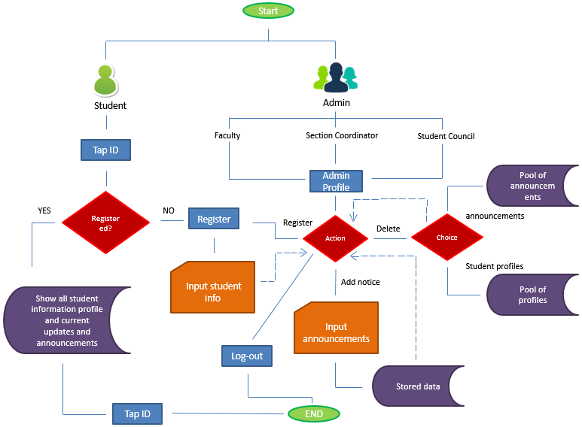

**Proposed Time-Table**